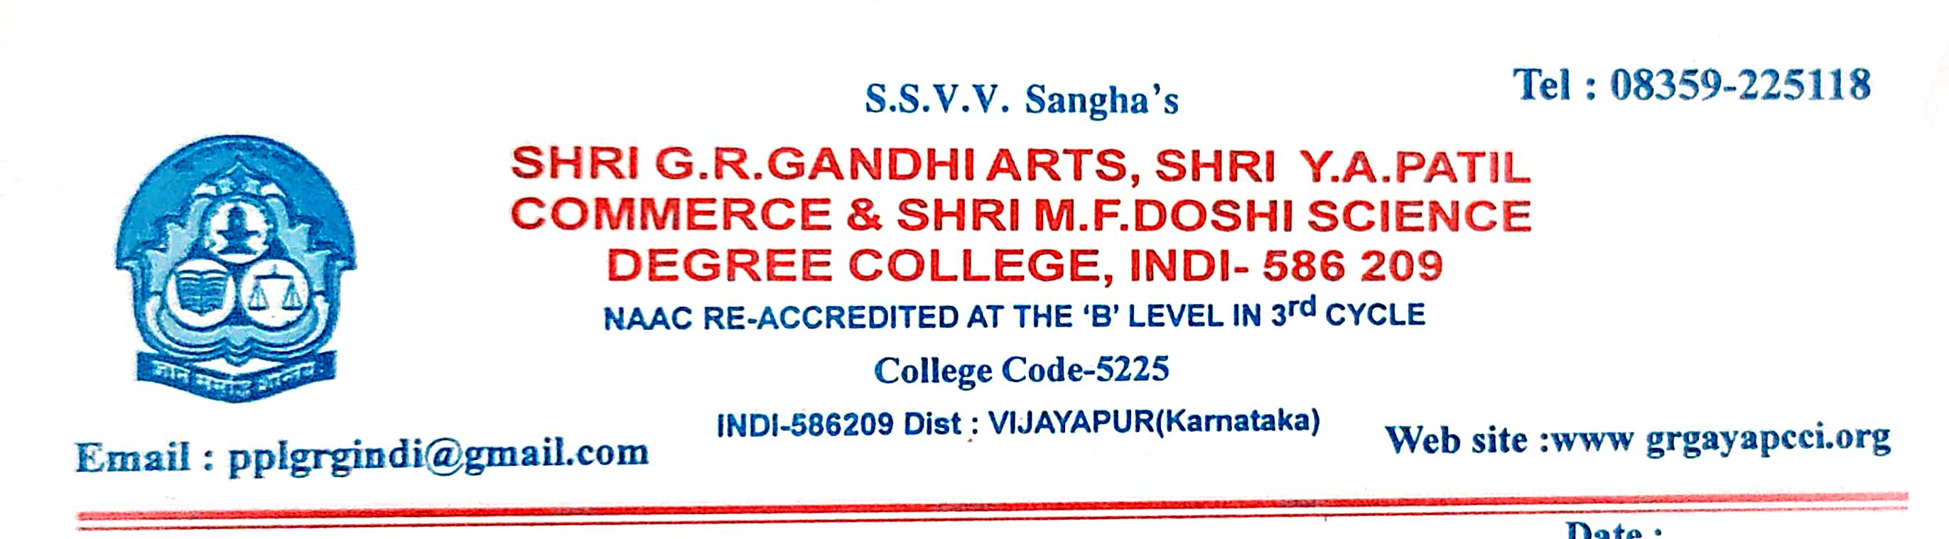
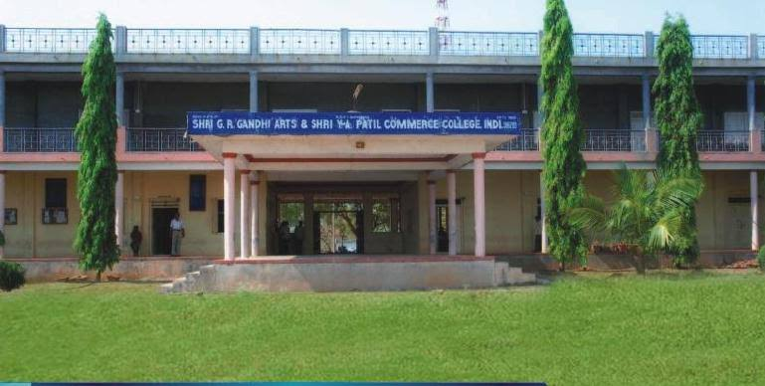

CRITERION VII - INSTITUTIONAL VALUES AND BEST PRACTICES

7.1.9 – Human Values and Professional Ethics

7.1.9 - Sensitization of students and employees of the Institution to the constitutional obligations: values, rights, duties and responsibilities of citizens.

7.1.9 - Sensitization of students and employees of the Institution to the constitutional obligations: values, rights, duties and responsibilities of citizens.
There are courses like “Indian Constitution”, “Foundations of Human Rights”,“Yoga for Healthy Living” and so on promoting national and global expectations of a civilised society. The College takes pride in grooming successful leaders among the students by conducting the Student Council election every year. The elected representatives are given leadership training to shoulder the responsibilities of organising college programmes with the support of other student volunteers. The institution conducts training programme for its new recruits to visualise the transformation of the marginalised along with the institutional values. Staff and students are instructed as directed by the government, and accordingly encouraged their participations in the national celebrations, observing Flag Day while taking oaths for promoting anti-untouchability, social and religious harmony and national integration. The College commemorates the milestones of India’s history with great honour instilling national integrity and patriotism. The Institution encourages participation of students in sports and games, and NSS at the national level to strengthen nationwide bond and adhere to the principle of unity-in-diversity. International Women's Day is celebrated every year with great zeal ensuring active participation of male and female staff and students to promote social environment free of gender bias.

SI.NO | NAME OF THE EVENTS | DATE
01 | Independence Day | 15th August
02 | National Service Scheme Day | 24th September
03 | Rastriya Ekata Divas | 31st October
04 | Constitution Day | 26th November
05 | Aids Day | 1st December
06 | Republic Day | 26th January
07 | Enironment Day | 5th June
08 | Sadbhavana Divas | 20th august
09 | Leagal Awareness Assistance | 17th July

INDEPENDENCE DAY
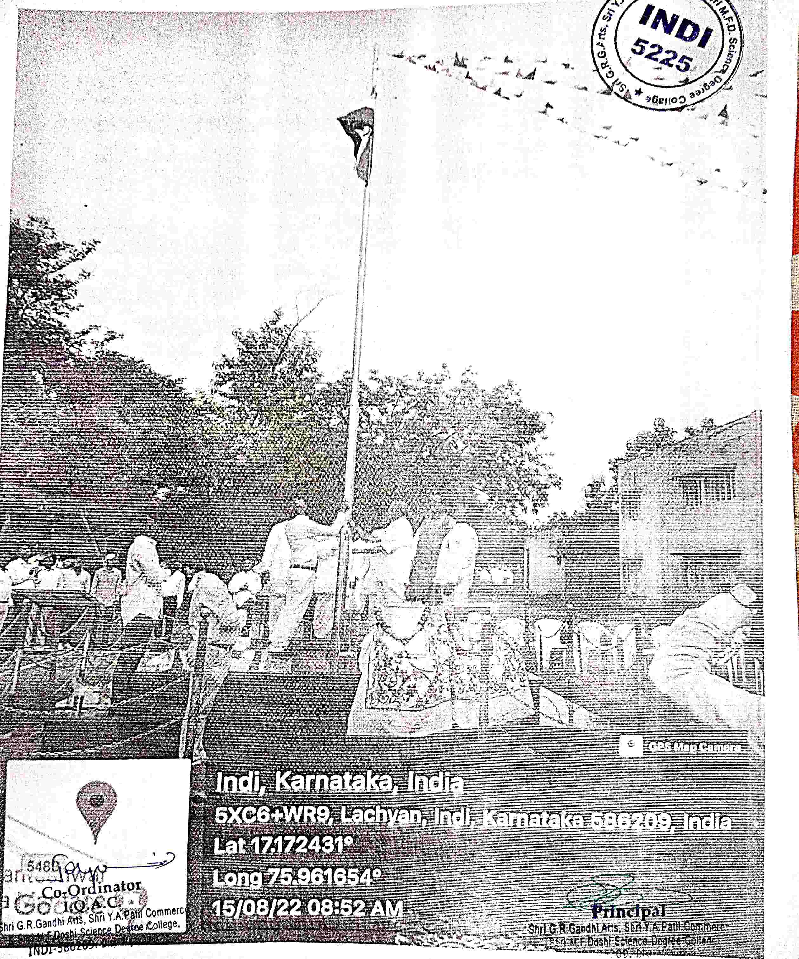
NATIONAL SERVICE SCHEME DAY
NATIONAL SERVICE SCHEME DAY

NATIONAL SERVICE SCHEME DAY
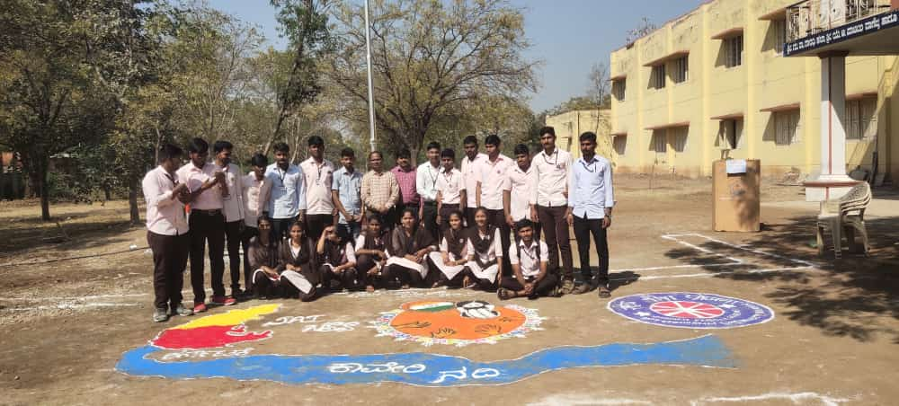

NATIONAL SERVICE SCHEME DAY
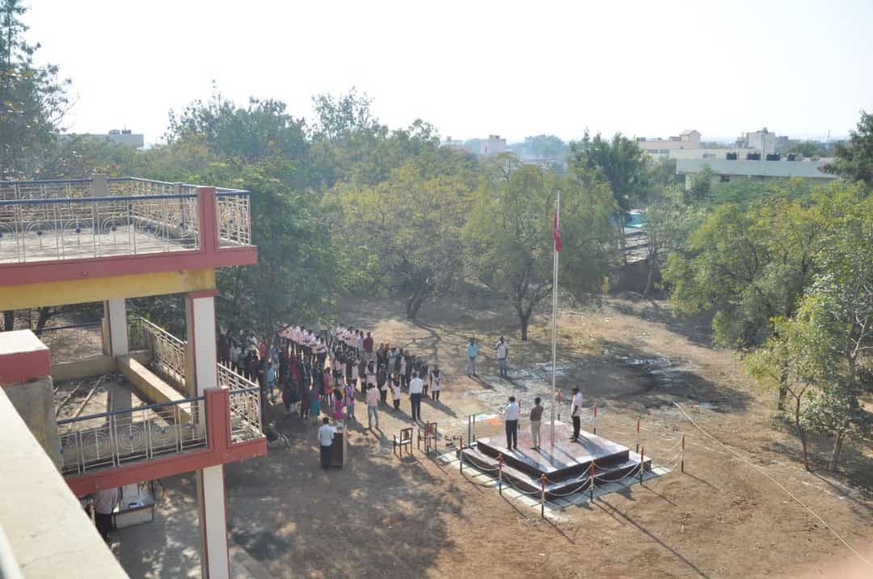
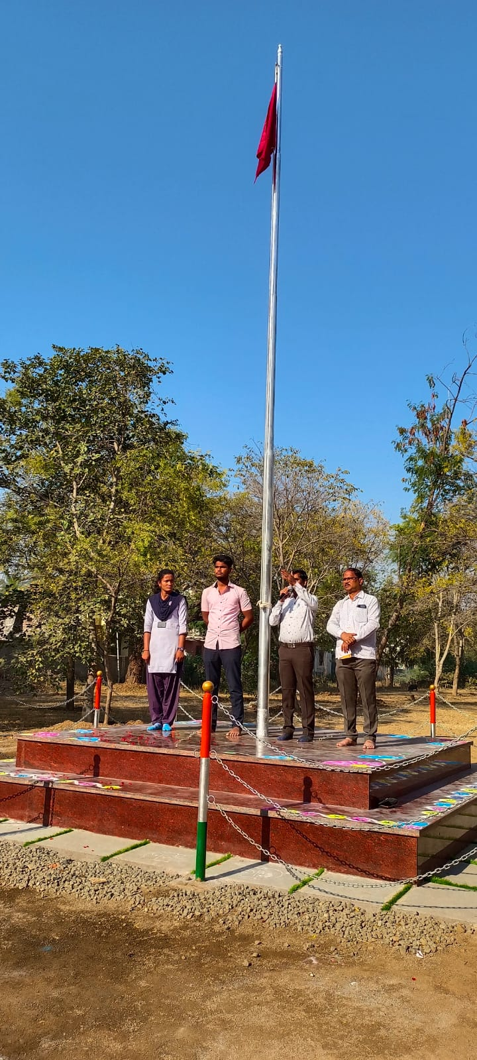
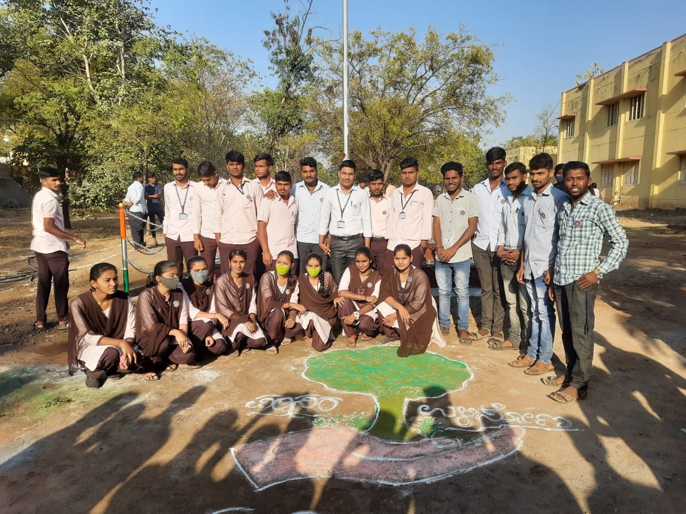

RASTRIY EKATA DIVAS
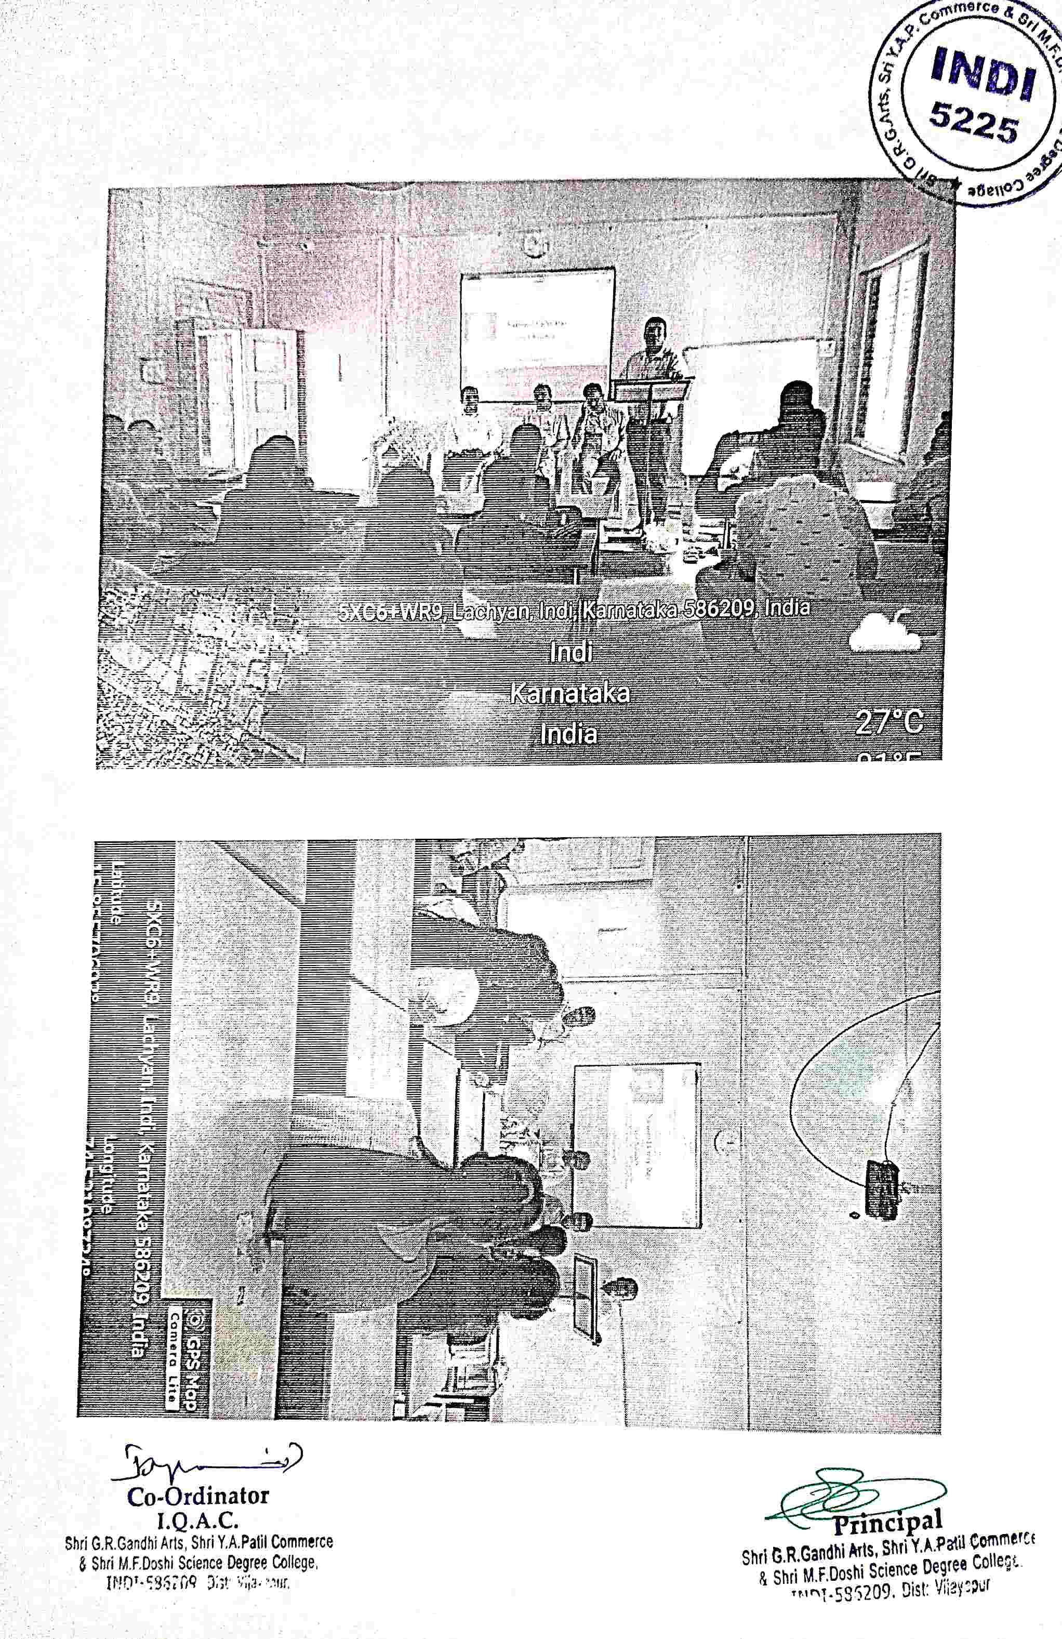

CONSTITUTION DAY
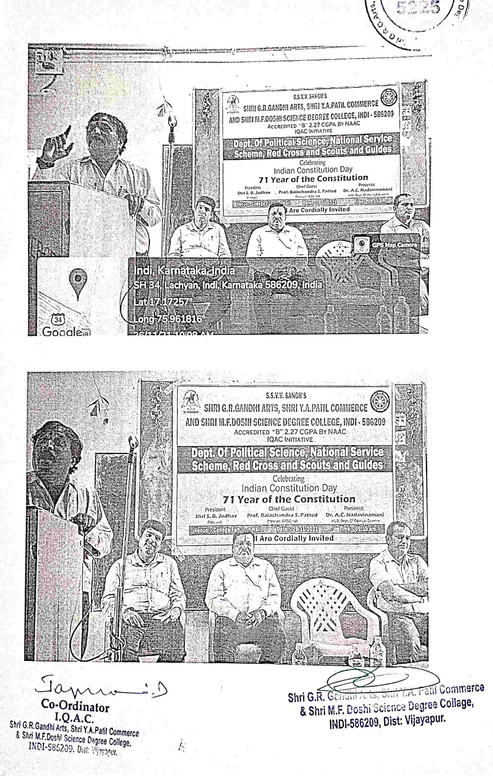

SADBHAVANA DIVAS
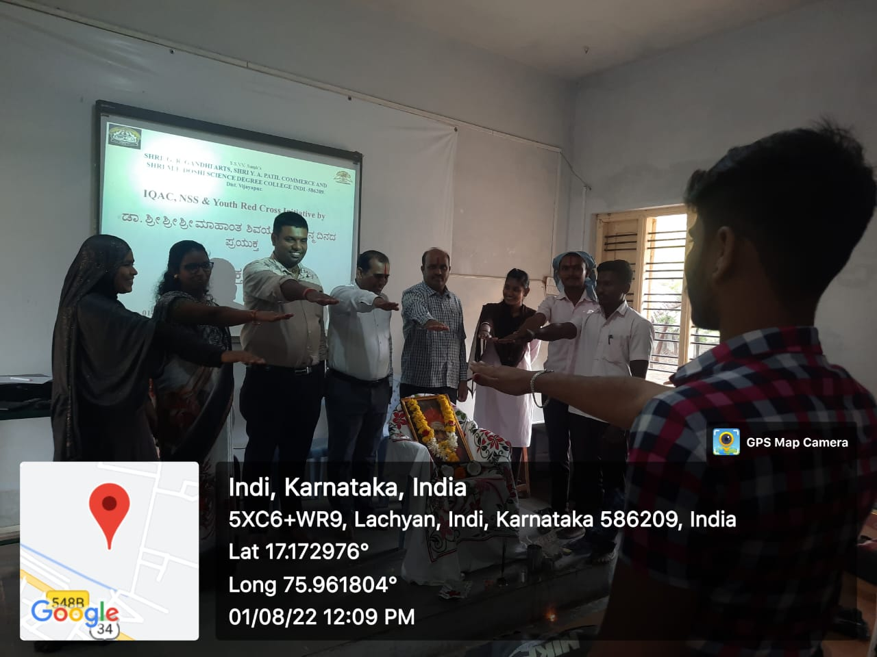

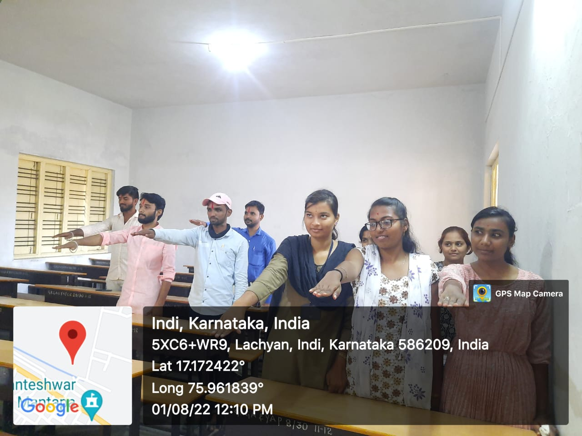

ENVIRONMENT DAY
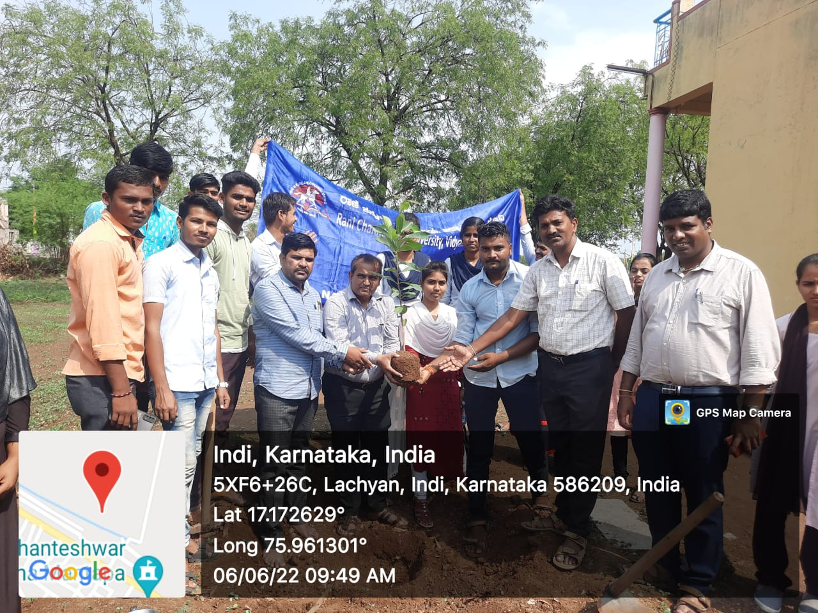

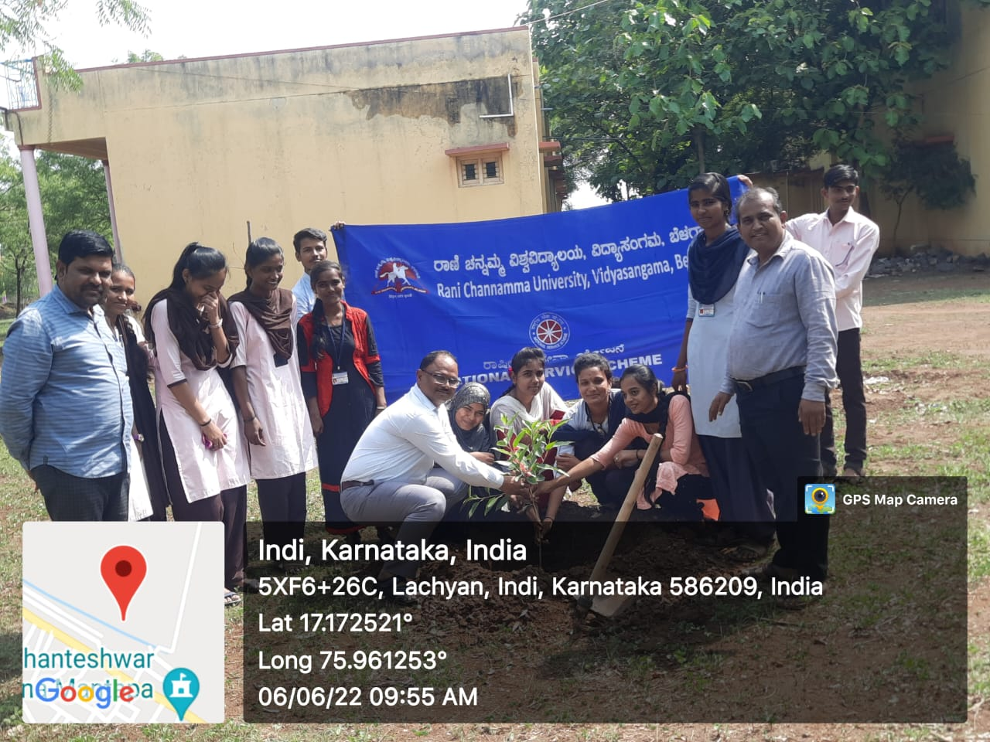
ESSAY COMPITITION FOR 15TH AUGUST
LEGAL AWARENESS ASSISTANCE

